TECHNOLOGY SYSTEMS 9th Grade
NAME ______________________

DATE _______________________
_
UNIT 3 – ENGINEERING DESIGN PRE- TEST

DIRECTIONS: Select the best answer. Write the correct answer on the line.
WORD BANK

- brainstorming D. engineering-design process G. set of steps
- communicate and test E. personal characteristics H. sketches and models
- constraints F. prototype I. transform

1. __________ The ___________________ includes identifying a problem, looking for ideas, developing solutions, and sharing solutions with others.

2. __________ Expressing ideas to others using ___________________ is an important part of the design process.

3. __________ Design involves a___________________, which can be performed in different sequences and repeated as needed.

4. __________ A group problem-solving design process in which each person presents ideas is called ___________________.

5. __________ Modeling and testing are used to ___________________ ideas into practical solutions.

6. __________ Engineering design is influenced by the___________________, such as creativity and resourcefulness of individuals and groups of people.

7. __________ A ___________________ is a working model used to test a design concept.

8. __________ Models are used to ___________________ design ideas and processes.
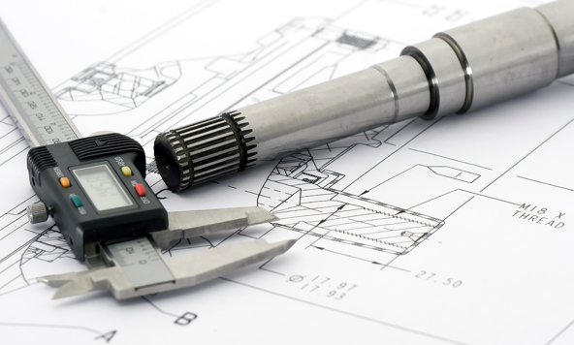

**Essay on the back

PARAGRAPH Answer each of the following prompts. I expect a PSSA prompt style response with an introductory sentence and supporting sentences with facts, evidence, examples, etc. Use your best spelling and punctuation. Do your best.

9. Explain why designs need to be continually critiqued and refined.
__________________________________________________________________________________________________
__________________________________________________________________________________________________
__________________________________________________________________________________________________
__________________________________________________________________________________________________
__________________________________________________________________________________________________
__________________________________________________________________________________________________
__________________________________________________________________________________________________
__________________________________________________________________________________________________
__________________________________________________________________________________________________
__________________________________________________________________________________________________
__________________________________________________________________________________________________
__________________________________________________________________________________________________
__________________________________________________________________________________________________
__________________________________________________________________________________________________
__________________________________________________________________________________________________

10. What are patents and what do they do for inventors
__________________________________________________________________________________________________
__________________________________________________________________________________________________
__________________________________________________________________________________________________
__________________________________________________________________________________________________
__________________________________________________________________________________________________
__________________________________________________________________________________________________
__________________________________________________________________________________________________
__________________________________________________________________________________________________
__________________________________________________________________________________________________
__________________________________________________________________________________________________
__________________________________________________________________________________________________
__________________________________________________________________________________________________
__________________________________________________________________________________________________
__________________________________________________________________________________________________
__________________________________________________________________________________________________

