NAME __________________________
DATE __________________________
Energy & Power Systems
What, where, when, why, and how are energy and power systems?

What is Energy?
*____________ is a ___________that is understood as the ability to perform _________.
*Since energy is a ____________, it can be _______________.
*This quantity can be assigned to any_____________, _______________, or ______________
of objects as a consequence of its _________________ state.
Different forms of energy include: _________________
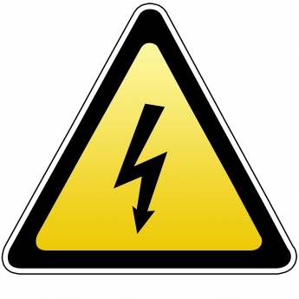
_________________
_________________
_________________
_________________
_________________
_________________
*Energy in one form can _______________ but the ____________ amount of energy will
___________ in another form. This fact of energy is a called a _______________ law.
*Any form of energy can be ______________ into another form.
*There are often __________ to the ______________ of the______________ to other forms of
energy, due to the __________ law of ______________________.

OVER

What are Power Systems?
*A __________ system is a network of electrical ______________ used to _________, transmit
and ___________ electric power.
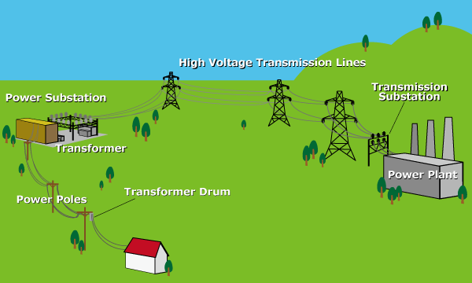
* An example of this is the Power _________ System which is also known as The __________.

*Power ____________ such as a coal power plant ___________ the power.
*The ________________ system of transmission substations, high voltage transmission lines, and power substations carries the power from the generating centers to the load centers.
*The _______________ system of power substations, transformers, power poles, and transformer drums feed the __________ to nearby homes, factories, and industries.
11 DIFFERENT TYPES of POWER SOURCES:
hydroelectric, ____________, nuclear, ____________, fuel cell, __________, geothermal/hydrothermal,
_________ power, ___________fuels, __________
What are the top three major fuel sources for today’s in the US? What powers most French homes? Why?
1._______________ 2. _______________ 3. ______________ ___________ _______________________

