UNIT 3
NAME ______________________

DATE _______________________

TECHNOLOGICAL SYSTEMS

INTERACTIONS

Coffee Anyone?

Use information from the website http://www.howstuffworks.com/coffee-maker.htm to research and complete questions regarding the parts and functions of a coffeemaker. You may only use Sections 1-5 of this website and the diagram found on the next page.

Identify the important parts and indicate what they do.

 | Part Name | Subsystem (see below) | Function Served
1 | Warming Plate
2 | Shower Head
3 | Bucket (Reservoir)
4 | White Tube
5 | Drip Area
6 | Orange Hot-Water Tube
7 | Orange Cold-Water Tube
8 | Switch
9 | Resistive Heat Element
10 | Heat Conductive Grease
11 | Temperature Sensor
12 | Thermal fuse
13 | One-Way Valve
14 | Filter and Basket
15 | Carafe
16 | Signal Lamp

What subsystem does each part belong to? Write the letter of the appropriate subsystem next to each of the parts listed above.

(T) Fluid Transportation System
(F) Filtering System
(H) Heating System
(S) Structural System
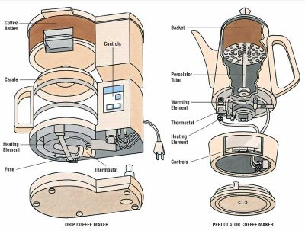
Describe how two of these subsystems interact with one another.

Describe how each of the subsystems is connected to other subsystems.

Give an example of how the malfunction of one of these subsystems could affect the function and quality of the entire system.

Draw and label a diagram of a subsystem within a system of the coffee maker.

