MATERIALS PROCESSING 20” x 18” x 29 ½” TOOL CHEST

BILL OF MATERIALS
PART |  | FINISHED SIZE |  |  | MATERIAL | QUANTITY
 |  | T | W | L
A | SIDE PANEL STILES | ¾” | 2 ¼” | 20 | hardwood | 4
B | SIDE PANEL RAILS | ¾” | 3” | 15” | hardwood | 4
C | CENTER PANELS (glue up strips) | ¾” | 15” | 15 ½” | hardwood | 2
D | FRONT RAILS | ¾” | 3” | 28” | hardwood | 2
E | TOP SHELF | ¾” | 16 $7/8$“ | 28” | hardwood | 1
F | TRAY GLIDES | 3/8” | ${11}/{16}$“ | 17” | hardwood | 8
G | BACK BOARD | ¾” | 20” | 28 ¾” | hardwood | 1
J | CORNER BLOCKS | ¾” | 3 ½” | 3 ½” | hardwood | 4
K | UPPER TRAY SIDES | ¾” | 2” | 17” | hardwood | 4
L | LOWER TRAY SIDES | ¾” | 3” | 17” | hardwood | 4
M | UPPER BACKS AND FRONTS | ¾” | 2” | 27 ${15}/{16}$“ | hardwood | 4
N | LOWER BACKS AND FRONTS | ¾” | 3” | 27 ${15}/{16}$“ | hardwood | 4
P | TRAY BOTTOMS | 3/16" | 17” | 27 ${15}/{16}$“ | veneer ply | 4
Q | TOP TRAY FACES | ¾” | 3 ¼” | 29 ½” | hardwood | 2
R | MIDDLE TRAY FACE | ¾” | 4” | 29 ½” | hardwood | 1
S | BOTTOM TRAY FACE | ¾” | 4 ½” | 29 ½” | hardwood | 1

HARDWARE
PART |  | SIZE | MATERIAL | QUANTITY
AA | Screws (F TRAY GLIDES) | ¾” | square drive | 20
BB | Screws (Q R S TRAY FACES) | 1 ¼” | square drive | 16
CC | Screws (Piano Hinge) | ½” | square drive | 40
DD | Piano Hinge | 29 ½” | brass or stainless | 1
EE | Lid Chains | 12” | brass or stainless | 2
FF | Tray Handles (student makes or supplies) |  | various | 8

SUPPLIES
ITEM | SIZE | MATERIAL | QUANTITY
wood Glue |  | Tight Bond
No. 10 biscuits | No. 10 | expanding glue biscuit | 20
brad nails (tray bottoms)
wood putty |  | wood matching
abrasive paper | sheet | 60 grit | 1
abrasive paper | sheet | 80 grit | 1
abrasive paper | sheet | 120 grit | 1
Abrasive paper | disc | 220 grit | 6
grain sealer
stain
polyurethane
application brush / rag |  |  | 3
steel wool |  | #000 | 1
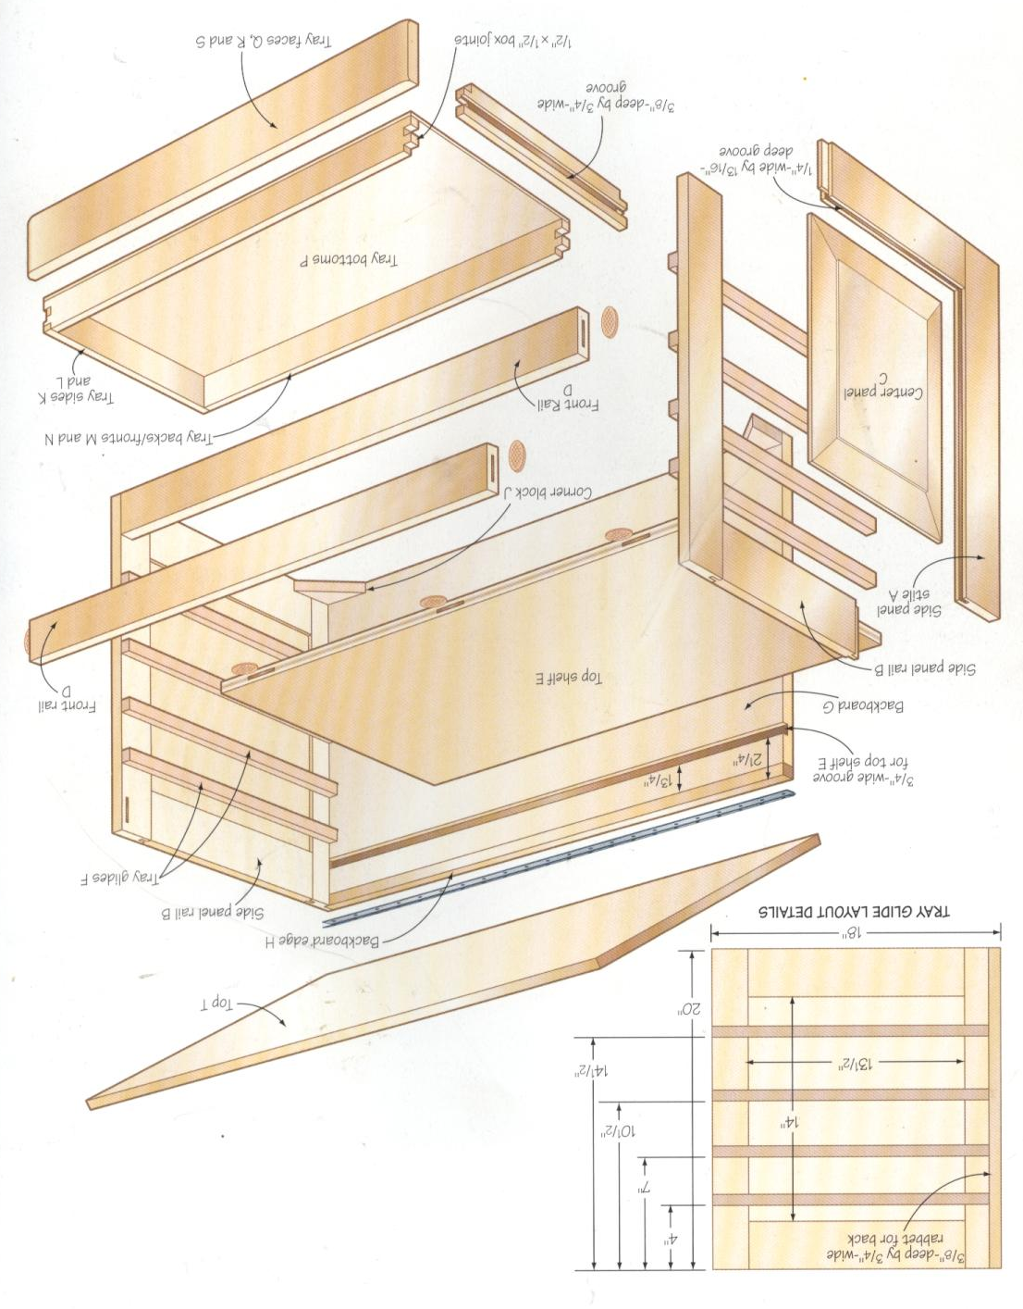
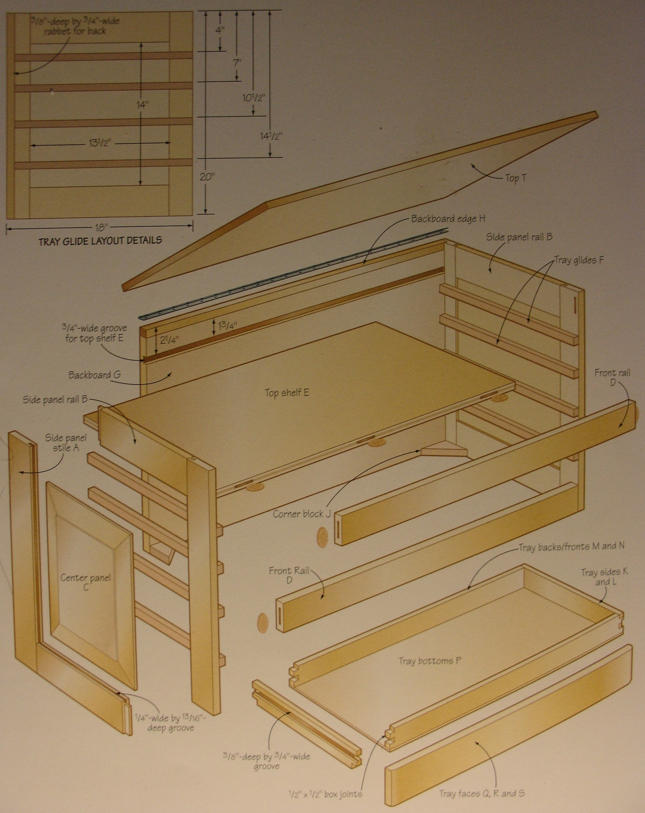

20” x 18” x 29 ½” TOOL CHEST
PROCESS SHEET

- C Center Panel – select stock 1” x 5 ½” x 16” minimum QTY 6

PROCESS MATERIALS
C Center Panel finished size: ¾” x 15” x 15 ½” qty 2
NOTE: Panel is made from 3 boards (¾” x 5” x 16”) glued together

- Radial Arm Saw / Miter Saw – if stock length is >16” cut it to 16”
- Inspect – check if rough stock is cupped
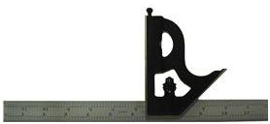
(Put a straight edge such as a combination square across the grain. Hold the stock up to a light source. If light peeks beneath the straight edge in the center, this is the cupped side. Mark it with an arrow pointing up.)

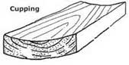

**If your stock is cupped like the diagram and its width is > 7 ¾”, carefully rip it to 6” using the table saw then
go to step C.

**If your stock is cupped and its width is < 7 ¾”, go to step C.

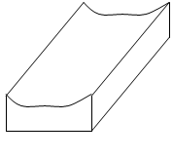
- Jointer – Fixes flat face - Makes a flat face *cupped side down (arrow pointing down) on the jointer table

- Jointer – Edge – Fix the better edge [Put the flat face against the fence]
- Table Saw – Cut to wood’s final width of 5”
[Put the jointed edge against the fence and the flat face on the table]
- Planner (small planer) – Thickness – reduce to the exact thickness of 7/8” <See Mr. Kush for a planer tip!!>
- Miter Saw - Cut off ¼” off of one end, then cut to exact length of 16”
**Remember to check what side of the line you need to cut on**
- Mark – Lightly write your name and the letter “C” on the bottom or top of this piece in PENCIL

Glue-Up

- Arrange the 3 boards with alternating growth ring orientation on top of 2 clamps with strips of paper
SEE DIAGRAM
- Apply a small amount of Tight Bond wood glue to each of the edges to be glued
- Prepare a damp sponge
- Place a third clamp in the center of the boards in the opposite direction of the clamps on the bottom
- Slowly tighten each of the clamps and use the sponge to clean any of the glue squeeze out

- T Top – select stock 1” x 5” x 32” minimum QTY 4

PROCESS MATERIALS
T Top finished size: ¾” x 19” x 31 ½”
NOTE: T TOP Panel is made from 4 boards (¾” x 4 ¾” x 32”) glued together

- Radial Arm Saw / Miter Saw – if stock length is >32” cut it to 32”
- Inspect – check if rough stock is cupped
(Put a straight edge such as a combination square across the grain. Hold the stock up to a light source. If light peeks beneath the straight edge in the center, this is the cupped side. Mark it with an arrow pointing up.)

**If your stock is cupped like the diagram and its width is > 7 ¾”, carefully rip it to 5” using the table saw then
go to step C.

**If your stock is cupped and its width is < 7 ¾”, go to step C.

- Jointer – Fixes flat face - gives a flat face *cupped side down (arrow pointing down) on the jointer table

- Jointer – Edge – Fix the better edge [Put the flat face against the fence]
- Table Saw – Cut to T Top’s final width of 4 ¾”
[Put the jointed edge against the fence and the flat face on the table]
- Planner (small planer) – thickness – Reduce to the exact thickness of 3/4” <Use the planer technique!>
- Miter Saw - Cut off ¼” off of one end, then cut to exact length of 32”
**Remember to check what side of the line you need to cut on
- Mark – Lightly write your name and letter “T” on the bottom or top of this piece in PENCIL
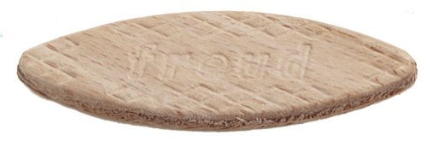
#10 BISCUIT
Biscuit Joints
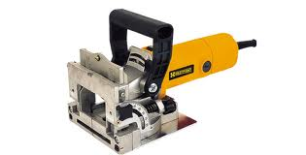
- Set the biscuit jointer to the No. 10 setting
- Set the biscuit jointer height of cut to 3/8”
- Get two scrap pieces of wood that are exactly ¾” thick
- Align and mark the scrap pieces of wood then use the biscuit jointer on a clean hard surface
- Test a No. 10 biscuit in the joint. Make adjustments as necessary and retest the cut.
- Use the diagram below to layout the biscuit joint locations

3”
8 ^{3/8}”
3”
8 ^{3/8}”

Glue-Up

- Arrange the 4 boards with alternating growth ring orientation on top of 3 clamps with strips of paper
SEE DIAGRAM
- Apply a small amount of Tight Bond wood glue to each of the edges to be glued
- Prepare a damp sponge
- Place a third clamp in the center of the boards in the opposite direction of the clamps on the bottom
- Slowly tighten each of the clamps and use the sponge to clean any of the glue squeeze out
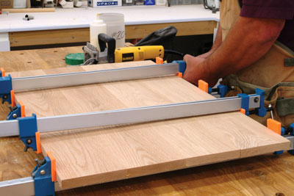

- A Side Panel Stiles – select stock 1” x 2 ¾” x 21”minimum QTY 4

PROCESS MATERIALS
A Side Panel Stiles Top finished size: ¾” x 2 ¼” x 20”

- Radial Arm Saw / Miter Saw – if stock length is >21” cut it to 21”
- Inspect – check if rough stock is cupped
(Put a straight edge such as a combination square across the grain. Hold the stock up to a light source. If light peeks beneath the straight edge in the center, this is the cupped side. Mark it with an arrow pointing up.)

**If your stock is cupped like the diagram and its width is > 7 ¾”, carefully rip it to 2 ¾” using the table saw then
go to step C.

**If your stock is cupped and its width is < 7 ¾”, go to step C.

- Jointer – Fixes flat face - gives a flat face *cupped side down (arrow pointing down) on the jointer table

- Jointer – Edge – Fix the better edge [Put the flat face against the fence]
- Table Saw – Cut to A Side Panel Stile’s final width of 2 ¼ ”
[Put the jointed edge against the fence and the flat face on the table]
- Planner (small planer) – thickness – Reduce to the exact thickness of 3/4” <Use the planer technique!>
- Miter Saw - Cut off ¼” off of one end, then cut to exact length of 20”
**Remember to check what side of the line you need to cut on
- Mark – Lightly write your name and letter “A” on the bottom or top of this piece in PENCIL

- B Side Panel Rails – select stock 1” x 3 ½” x 16” minimum QTY 4

PROCESS MATERIALS
B Side Panel Rails finished size: ¾” x 3” x 15”

- Radial Arm Saw / Miter Saw – if stock length is >16” cut it to 16”
- Inspect – check if rough stock is cupped
(Put a straight edge such as a combination square across the grain. Hold the stock up to a light source. If light peeks beneath the straight edge in the center, this is the cupped side. Mark it with an arrow pointing up.)

**If your stock is cupped like the diagram and its width is > 7 ¾”, carefully rip it to 3 ½” using the table saw then
go to step C.

**If your stock is cupped and its width is < 7 ¾”, go to step C.

- Jointer – Fixes flat face - gives a flat face *cupped side down (arrow pointing down) on the jointer table

- Jointer – Edge – Fix the better edge [Put the flat face against the fence]
- Table Saw – Cut to A Side Panel Stile’s final width of 3”
[Put the jointed edge against the fence and the flat face on the table]
- Planner (small planer) – thickness – Reduce to the exact thickness of 3/4” <Use the planer technique!>
- Miter Saw - Cut off ¼” off of one end, then cut to exact length of 15”
**Remember to check what side of the line you need to cut on
Keep the larger cutoff piece.
- Mark – Lightly write your name and letter “B” on the bottom or top of this piece in PENCIL

5. GROOVE - A Side Panel Stiles & B Side Panel Rails – ¼” x ${13}/{16}$” Groove

- Table Saw - Set the inside face of the table saw blade ¼” away from the fence
- Set the height of the blade to ${13}/{16}$”
- Run a test ¾” board through the table saw – check the blade height and adjust as necessary
- Push all of the 8 boards through the blade
- Reverse the boards and run them through the blade again
- This process will center the groove – a small strip of material may be left in the center of the groove
- Adjust the fence and run a cleaning pass in the center of each groove
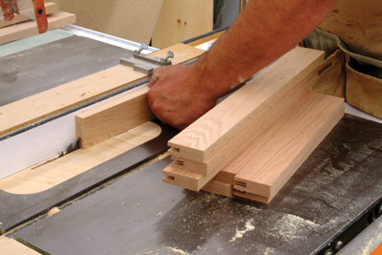
3/4"
1/4"
1/4"
${13}/{16}$”
GROOVE

6. TENON - B Side Panel Rails – ¼” thick x ¾” long Tenon QTY 4

- Table Saw – Using clamps, attach a perfectly straight piece of MDF to the table saw fence. This is a sacrificial
fence. It will cut by the blade instead of the real fence.
- Select the dado blade and set it up to cut ¾” with a height of ¼” above the table
- Attach a true board (perfectly straight MDF if preferred)-
to the miter gauge to safely support the cutting of the tenon (see diagram below)
- Run a test ¾” thick board through the table saw – check the blade height and width and adjust as necessary
- Test that the tenon fights snugly in the grooves
3/4"
1/4"
1/4"
- Push all of the 4 B Side Panel Rail boards through the blade
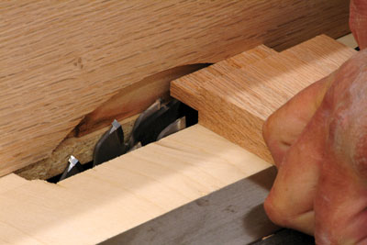
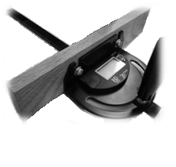

3/4"

TENON

7. C Center Panel – 15” x 15 ½” QTY 2
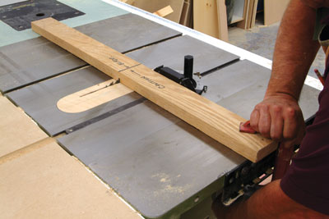
- Radial Arm Saw – cut both of the C Center Panels to the finished size of 15” x 15 ½”

- Table Saw
- Carefully remove the blade guard.

- Change the blade to a thick kerf rip blade.

- Lower the blade below the table surface and clamp a strong, long, and perfectly straight MDF board across its top dead center at 90° to the blade face. Use the miter gauge to align the board and then clamp the board to the table at both ends.

- Raise the table saw blade 1/32” above the table surface.

- BE CAREFUL! THE BLADE DOES NOT HAVE A GUARD ON IT!
IT WILL CUT YOU! BE EXTRA CAREFUL!

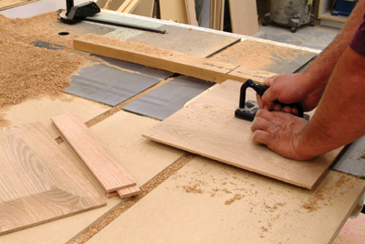
- Use a push pad in the center of each panel to push all four sides of both center panels along the guide board and across the blade. Slow, steady passes across the blade will yield the best cuts and reduce sanding after the cuts have been completed. The push pad in the center of each panel will help the panel from tipping as the edges get thinner.

- Repeat the process, raising the blade 1/32” after each series of passes until the edges of the panels fit loosely into the stile and rail grooves.

- Be sure the panels can move freely inside the grooves to allow for expansion and contraction of the wood.
8. C Center Panel ASSEMBLY – 15” x 15 ½” QTY 2 - Assembly

- ½ Sheet Sander & Random Orbit Sander – completely sand the entire panel until it is smooth like glass
- Assemble - Assemble one panel – see the diagram THE CENTER PANEL SHOULD FLOAT IN THE GROOVES
- Glue - Put Tight Bond wood glue on the tenons
- Clamp - Use two clamp to secure the pieces – use a piece of foam or rubber on the clamp ends to keep from
damaging the assembly’s edges
- Measure - Use a metal yardstick and measure the diagonal measurement from corner to corner.
- If the diagonal measurements are the same, the panel is square.
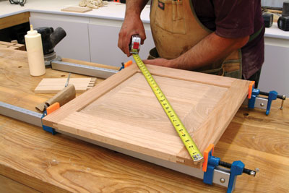
RAIL

STILE
STILE
Notice that the grain runs parallel to the rails.

RAIL

9. C Center Panel Assembly – 15” x 15 ½” QTY 2 - RABBET 3/4” x 3/8”

- Table Saw – Place the auxiliary fence on top of the standard table saw fence. This is a sacrificial fence. It will cut by the blade instead of the real fence.

- Insert a dado blade and raise it to 3/8” above the table.
- Set the fence at ¾” – double check this measurement with a square
4. Cut ONLY the REAR INSIDE FACE of each side panel (STILE) – see the diagram below

Notice that only one stile gets the 3/4" x 3/8” rabbet cut.

10. Center Panel Assembly & D Front Rails QTY 2 – biscuit joint

- Mark the center on the end of both side of D Front Rails – See Diagram A
- Align D Front rail flush with the side of the Center Panel assembly.
- Transfer the center mark from D Front Rail to the side of the Center Panel assembly – See Diagram B
- Do this same operation on the bottom of the Center Panel assembly

D Front Rails
D Front Rail
D Front Rail
Center Panel Assembly
Center Panel Assembly

DIAGRAM A

- Set the biscuit jointer to the No. 10 setting
DIAGRAM B
- Set the biscuit jointer height of cut to 3/8”
- Get two scrap pieces of wood that are exactly ¾” thick
- Align and mark the scrap pieces of wood then use the biscuit jointer on a clean hard surface
- Test a No. 10 biscuit in the joint. Make adjustments as necessary and retest the cut.
- Make the cuts on the center panel and on the D Front Rails – See Diagram C

- DRY FIT THE PARTS – DO NOT GLUE THEM
DIAGRAM C
#10
D Front Rail
Center Panel Assembly
Center Panel Assembly
#10
#10
D Front Rail
#10

11. E Top Shelf Panel – select stock 1" X 5 ^{5/8}” x 29 minimum QTY 3
PROCESS MATERIALS
E Top Shelf finished size: 3/4" X 16 ^{7/8}” x 28 QTY 1

****Plane all pieces to 7/8” thickness before it is glued up.

**** Glue up the pieces at the rough length of 29”.

NOTE: Panel is a glue up three boards with biscuits

***Use 4 biscuits to join each of the three pieces. Use appropriate the same spacing as you did for the lid.

AFTER the PANEL HAS BEEN GLUED

- Radial Arm Saw– trim the best edge so it is even.

- Radial Arm Saw – cut the panel to its final length of 28”

- Table Saw – IF NECESSARY - Cut to wood’s final width of 16 7/8”

- Paner – Plane to the final thickness of ¾”

- Mark – Lightly write your name and the letter “E” on the bottom or top of this piece in PENCIL

12. E Top Shelf Panel – biscuit joints

- Dry fit the Center Panel Assembly and the D Front Rails using biscuits
- Use a bar clamp to gently hold the complete assembly together
- Slide E Top Panel into the assembly – this is the top compartments base
- The bottom of E Top Panel should be flush with the bottom of D Top Front Rail
- Turn the whole cabinet upside down
- Measure 7” increments and mark 3 locations for biscuit joints. Place the marks on both D Top Rail and E Top Shelf Panel – See Diagram

NOTE: The cabinet is placed upside down for this operation.
D Front Rail
D Front Rail
Center Panel Assembly
Center Panel Assembly
E Top Shelf Panel
7”
7”
CENTER

- Set the biscuit jointer to the No. 10 setting
- Set the biscuit jointer height of cut to 3/8”
- Get two scrap pieces of wood that are exactly ¾” thick
- Align and mark the scrap pieces of wood then use the biscuit jointer on a clean hard surface
- Test a No. 10 biscuit in the joint. Make adjustments as necessary and retest the cut.
- Make the cuts on E Top Shelf and on D Front Rail – See Diagram C

- DRY FIT THE ALL OF THE PARTS – DO NOT GLUE THEM

13. T Tray Glides– select stock 1” x 1” x 18” minimum QTY 8

PROCESS MATERIALS USE SCRAP WOOD FROM THE WOOD RACK FOR THIS OPERATION
T Tray Glides finished size: ¾” x 11/16” x 17”

- Radial Arm Saw / Miter Saw – if stock length is >18” cut it to 18”
- Inspect – check if rough stock is cupped
(Put a straight edge such as a combination square across the grain. Hold the stock up to a light source. If light peeks beneath the straight edge in the center, this is the cupped side. Mark it with an arrow pointing up.)

**If your stock is cupped like the diagram and its width is > 7 ¾”, carefully rip it to 2” using the table saw then
go to step C.

**If your stock is cupped and its width is < 7 ¾”, go to step C.

- Jointer – Fixes flat face - gives a flat face *cupped side down (arrow pointing down) on the jointer table

- Jointer – Edge – Fix the better edge [Put the flat face against the fence]
- Table Saw – Cut to T Side Panel Stile’s final width of 11/16”
[Put the jointed edge against the fence and the flat face on the table]
- Planner (small planer) – thickness – Reduce to the exact thickness of 3/8” <Use the planer technique!>
- Miter Saw - Cut off ¼” off of one end, then cut to exact length of 17”
**Remember to check what side of the line you need to cut on
Keep the larger cutoff piece.
- Mark – Lightly write your name and letter “T” on the bottom or top of this piece in PENCIL

14. T Tray Glides & Center Panel Assembly - QTY 2

- Layout the location for all of T Tray Glides both sides at the same time!
**THE STRIPS ARE ATTACHED AT POINTS MEASURED FROM THE TOP EDGE** See Diagram A

14 ½”
4”
7”
10 ½”
20”
14”
13 ½”
18”
DIAGRAM A
T TRAY GUIDE
T TRAY GUIDE
T TRAY GUIDE
T TRAY GUIDE

- Layout the hole locations on T Tray Guides THE LEFT And RIGHT SIDE ARE DIFFERENT! – See Diagram B
- Select an appropriate drill bit to pre-drill the wood screw holes
- DRILL PRESS – place a piece of cardboard on the drill press table – this will help eliminate scratches from the table
- DRILL PRESS – use the depth nuts to set the appropriate pre-drilling depth
- DRILL PRESS – test the drill press depth with a scrap piece of wood
that is 1 ½” thick (or two ¾” thick boards) – adjust the dept as necessary
- DRILL PRESS – use a soft jaw clamp to secure the T Tray Guides one at a time and pre-drill the holes
- DRILL PRESS – install the countersink bit into the drill press and use the depth nuts to set the dept
- DRILL PRESS – counter sink the predrilled holes to the appropriate depth – the screw head should be flush or
sunk slightly below the surface of the wood
T TRAY GUIDE LEFT x 4
11/16”
3/8”
1 1/8”
11/16”
3/8”
3/4”

T TRAY GUIDE RIGHT x 4
11/16”
3/8”
1 1/8”
11/16”
3/8”
3/4”

- Wet a paper towel or rag for cleaning glue squeeze out
- Use a small amount of Tight Bond wood glue - apply it with a brush to the Center Panel only
- Select 16 flat head wood screws ¾” long – use a screwdriver (NOT A DRILL) to install the screws

15. G Backboard – select stock 1” x 5” x 29 3/4” minimum QTY 4

PROCESS MATERIALS
G Backboard finished size: 3/4” x 20 x 28 ¾”

- Table Saw – Cut to G Backboard’s final width of 19 ½”

- Radial Arm Saw – Cut to G Backboard’s final length of 28 ¾”

- Mark – Lightly write your name and letter “G” on the bottom or top of this piece in PENCIL

17. G Backboard – finished size: 34” x 19 ½” x 28 ¾” minimum QTY 1 DADO OPERATION

PROCESS MATERIALS
G Backboard dado: ¾” wide x 3/8” deep dado groove SEE DIAGRAM BELOW

- Table Saw – Place the MDF auxiliary fence on top of the table saw fence. This is a sacrificial fence. It will cut by the blade instead of the real fence.

- Insert the ¾” stacked dado blade and raise it to 3/8” above the table.
- Set the fence 1 ¾” from the dado blade.
DO NOT USE THE SCALE ON THE FENCE…USE A SQUARE TO CHECK THIS MEASUREMENT!!
- Cut a test piece and check the depth and thickness of the cut. It should be ¾” wide x 3/8” deep.

3/4” Wide
3/8” Deep
Dado Groove
2 1/4”
G Backboard 34” x 19 1/2” x 28” ¾”

19. Top Shelf E & Top Rail D Assembly
1. Align Top Shelf E and Top Rail D and dry fit the joints with biscuits.
2. The clamps will pull the joints together later.
3. If everything fits snug, remove the biscuits and use a sander to remove all of the pencil marks.
4. Apply glue to the busicuts and reinsert them into the joints.
4. Put a thin bead of glue on the edge of E Top Shelf.
5. Use three bar clamps and clamp the assembly together.
6. The next day after the joint is completely dry, sand the top edge of the joint so that it is flush.

E TOP SHELF

#10
#10
#10
D TOP RAIL

20. Partial Case Assembly

- Get a wet paper towel ready for cleaning any excess glue squeezeout.
- The case can now be assembled using glue on the biscuits and along both side of the E Top Shelf
- Put glue inside the dado of both side panels.
- Pur glue on the edges of the top shelf.
- E Top Shelf will be held more securely once its back edge is placed in the backboard’s groove
- When all parts are aligned properly, clamp the case with four clamps. Align the clamps on top of the top and bottom rail.
- .BE SURE TO USE WOOD BLOCKS ON THE JAWS OFCLAMPS. IF YOU DO NOT USE BLOCKS, YOU WILL HAVE JAW MARKS ON YOUR PROJECT.

21. J CORNER BLOCKS

PROCESS MATERIALS
J Corner Blocks finished size: ¾” x 3 ½” x 3 ½” Qty. 4

- USE SCRAP WOOD FROM THE WOOD RACK FOR THIS OPERATION
- Radial Arm Saw / Miter Saw – if stock length is >18” cut it to 18”
- Inspect – check if rough stock is cupped
(Put a straight edge such as a combination square across the grain. Hold the stock up to a light source. If light peeks beneath the straight edge in the center, this is the cupped side. Mark it with an arrow pointing up.)

**If your stock is cupped like the diagram and its width is > 7 ¾”, carefully rip it to 4” using the table saw then
go to step C.

**If your stock is cupped and its width is < 7 ¾”, go to step C.

- Jointer – Fixes flat face - gives a flat face *cupped side down (arrow pointing down) on the jointer table

- Jointer – Edge – Fix the better edge [Put the flat face against the fence]
- Table Saw – Cut to J Corner Blocks final width of 3 ½”
[Put the jointed edge against the fence and the flat face on the table]
- Planner – thickness – Reduce to the exact thickness of 3/4” <Use the planer technique!>
- Miter Saw - Cut off ¼” off of one end, then cut to exact length of 7 ¼”
**Remember to check what side of the line you need to cut on
Keep the larger cutoff piece.
- Miter Saw – Using a combination square, mark the board 3 ½”. Adjust the miter saw’s angle to 45° to the
left. Cut the board from corner to the measurement of 3 ½”. Do this again but adjust the miter saw’s angle to 45° to the right. Do this for a total of four pieces.
**Remember to check what side of the line you need to cut on**

- Mark – Lightly write your name and letter “J” on the bottom or top of these pieces in PENCIL

22. J CORNER BLOCKS

ASSEMBLY – Daigram below

- The four J corner blocks fit into the bottom of the corners of the case. The J corner blocks SHOULD NOT be flush with the bottom of the case.
- Put glue on the two edges of the corner blocks, but not the angle edge.
- Select a finishing nail or use the air stapler with 1 ¼” staples to attach the blocks.
- IF YOUR CASE IS NOT SQUARE, DO NOT FORCE THE BLOCKS TO MAKE YOU CASE SQUARE!
- Use shims a necessary behind the blocks for a tight glue joint. See Mr. Kush for help with this.

23. K Upper Tray Sides Finished Size: ¾” x 2” x 17” QTY 4

L Lower Tray Sides Finished Size: ¾” x 3” x 17” QTY 4

M Upper Backs and Fronts Finished Size: ¾” x 2” x 27 15/16” QTY 4

N Lower Backs and Fronts Finished Size: ¾” x 3” x 27 15/16” QTY 4

PROCESS MATERIALS

- Use the same procedure that you have use for processing all other parts – ORDER OF OPERATIONS
- Be sure to check the wood rack before cutting a new board.

24. Tray Bottoms Finished Size: 3/16” x 17” x 27 ^{15/16}” QTY 4

- Use the table saw and the radial arm saw to process these pieces from lauan sheets.

