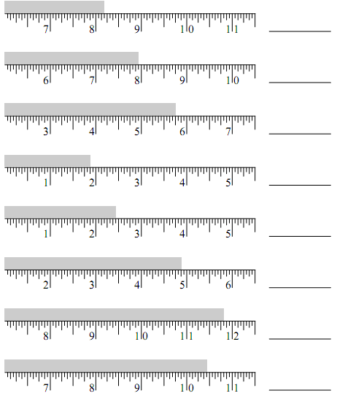**NAME _______________________________ DATE_______________ SCORE ______ / 16**

**H**

**G**

**F**

**E**

**D**

**C**

**B**

**A**

**MEASURING PRACTICE 2**

**M**

**L**

**K**

**J**

**I**

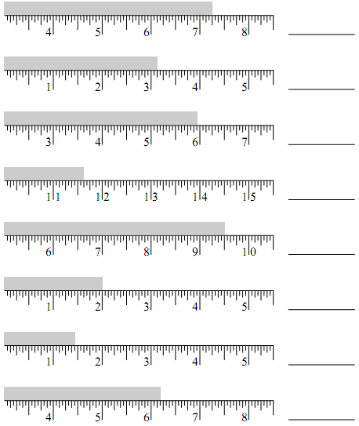

**N**

**O**

**P**