FOUNDATIONS of TECHNOLOGY 9th GRADE

Technology’s Impact & Influence on Historical Ages
Presentation Activity

Paleolithic Age
Mesolithic Age
Neolithic Age
Bronze Age
Iron Age
Middle Ages
Renaissance / Reformation / Enlightenment
Industrial Age
Information Age

DIRECTIONS: Create a PowerPoint presentation based on your selected historical age. Use the checklist below as you develop the presentation.
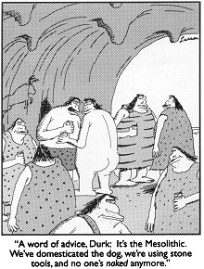
Explain:
- Basic description of the age
- Artifacts/tools from the Age with some examples
- What impact did technology have on the history of the age

GRAPHICS:
- Description of the Age Graphics
- Artifacts from the Age Graphics
- Impacts of the Technology on History Graphics

- Use appropriate graphics and images
- Use video if relevant and appropriate

- The presentation must have a sources page (MLA) use this link to help you with the citations: http://citationmachine.net/
- Be knowledgeable and present the information to the class on your assigned day.

