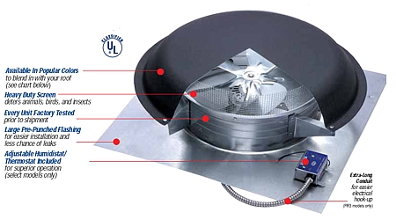**“If You Can’t Stand the Heat”**

Name:

Name:

Name:

Date:

**Design Brief**

**Situation:**

The efficiency of home cooling systems greatly affects household energy use and costs. Air conditioners must work hard to cool a home that is poorly insulated against the summer heat. Shingles heat up in the sun and can turn attic spaces into ovens that reach 155 degrees F. Placing a hot oven next to an area you want kept cool does not make sense. Reducing the temperature in the attic can greatly lower the energy consumption of the home’s cooling system.

**Lesson 3 Big Idea:** Knowledge gained from other fields of study has a direct effect on the development of technological products and systems.

**Challenge**

***Design an automatic, active ventilation system that will cool an attic space when it reaches a set temperature.***

**Requirements**

1. The system must include an **adjustable thermal detector**, a **switch system**, and a **motorized fan**.
2. The system components must be contained within the roof structure and function ***without human interaction***.
3. The system components must be securely affixed to the interior of the roof.
4. The roof must maintain its shape and integrity with respect to the effects of weather.
5. The ventilation system must ***activate*** when the temperature reaches **120 to 130 degrees Fahrenheit** and ***deactivate*** when it goes below this range.
6. The thermal detector ***must be adjustable*** to allow for **calibration**.
7. The roof vent must be able to automatically open to vent the heat and close when it is cooler without human intervention.
8. The roof ***must*** fit tightly to the house.

### Resources

The following parts and materials may be used to design and construct your active system:

* Wires 22 AWG solid core
* Bimetallic strip
* Cardboard and wood
* Tape
* Electric motor holder
* 6 wires with alligator clips
* 1” x 2” conductive material
* Hot glue gun & glue
* Other materials possible at request
* High-speed electric motor
* Propeller
* Batteries, AA
* Battery snap, AA
* Assorted hardware

**Procedure**

1. Form your design team and select the leader.
2. Design your solution using the ***Student Design Worksheet*** to document your work.
3. Present your design idea to Mr. Kush or another group and discuss if the design will work.
4. Construct your roof according to the specifications listed below.
5. Adapt the roof to fit your cooling system components.
6. Install the cooling system.
7. Test and adjust the system as needed.
8. Present and demonstrate your solution to the class.

### Basic Roof Specifications

***Two*** Rectangular roof pieces 12” x 20” or ***one*** piece 24” x 20” ***Two*** triangular gables4” tall

4”

12”

20”

12”

* (drawings are not to scale).
* Assemble parts so that the ridge of the roof is sealed with tape and the gables are 18” apart. See drawings:

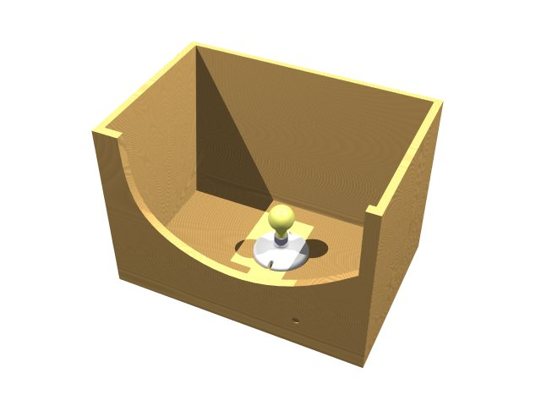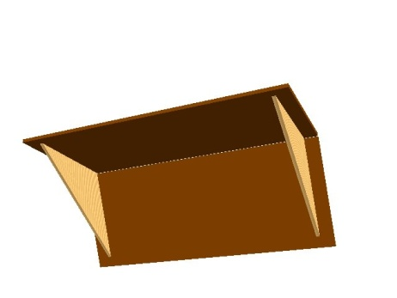

18”

**gable**



**roof ridge**

Your system fits in here

### Test Box (House) Specifications

The test box will have an open top that should match the gables of your roof. A light bulb will heat the box and trigger your cooling system to turn on.

light bulb

12”

**“If You Can’t Stand the Heat”**

Name:

Name:

Name:

Date:

**STUDENT DESIGN**

**WORKSHEET**

**Identify the problem**: ____________________________________________________ _______________

________________________________________________________________________ ___________________

**Criteria**: ________________________________________________________________ _____ _____________

________________________________________________________________________ ___________________

**Constraints**: ____________________________________________________________ _____________

________________________________________________________________________ ___________________

**Brainstorming and Generating Ideas**:

1. **Each** group member must create a **brainstorm list** and then **sketch** the **solution ideas** in the Engineering Design Journal. The parts of the sketch must be **labeled**. (If you prefer, sketches may be done on graph paper. Later, the brainstorming list and the sketches will be attached to this paper.)
2. Develop your ***best i***dea from your group of ideas.
3. **Present** your best solution to the group. The group will then select the **best** solution.
4. **Change** the design as necessary with **input** from the group.
5. **Sketch** the final design on graph paper and **label** all of the parts.
6. Put **all** of the group names and the **date** on this paper.

**Exploring Possibilities**: Make a “+ and –” chart next to each of these “best ideas” and list advantages and disadvantages of the design.

**Selecting an Approach: ______________________________________________________________________________**

________________________________________________________________________ ___________________

**Testing and Evaluating:** __________________________________________________ _____________

________________________________________________________________________ ___________________

________________________________________________________________________ ___________________

# Refining the Design: _________________________________________________________________________________

________________________________________________________________________ ___________________

________________________________________________________________________ ___________________

________________________________________________________________________ ___________________